|  |  |
| --- | --- |
| **Name:- Aryan Dilipbhai Langhanoja** | **Roll Number:- 92200133030** |
| **Subject Name and Code:-** Foundation Skills On Sensor Interfacing (01CT1103) | **Date of Experiment:- 15-12-2022** |

|  |  |
| --- | --- |
| Task:- |  |

* Interface MQ-6 Gas sensor with arduino uno development board and turn on the buzzer/led if gas leakage is being detected.

|  |  |
| --- | --- |
| Components: |  |

* Arduino Uno R3
* Gas Sensor
* Jumper Wires (Male To Male)
* Buzzer
* Laptop Or PC

|  |  |
| --- | --- |
| About the Project:- |  |

* In thisproject, we are going to interface Gas Sensor with Arduino. In that we will VCC to +5V and ground to the GND pin of Arduino. And the Remaining to pins of Sensor is connected to the analog pin of the Arduino.
* After that we will connect Buzzer for the safety purpose. For that we will connect the positive pin of Buzzer to the Digital pin 7 and Negative pin the Ground.

|  |  |
| --- | --- |
| Schematic:- |  |

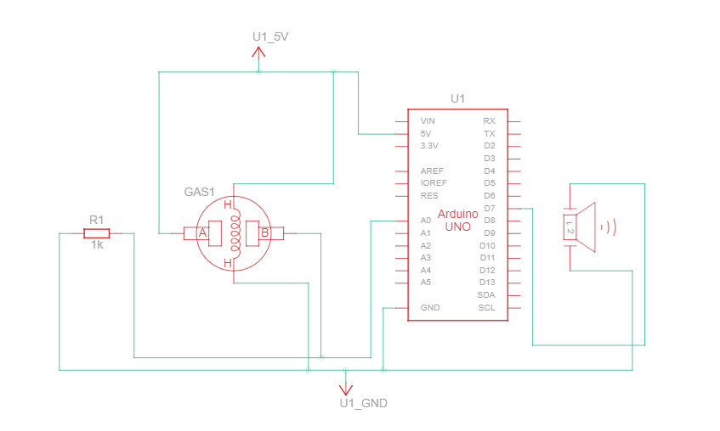

|  |  |  |
| --- | --- | --- |
| Output:- (you circuit implementation |  |  |

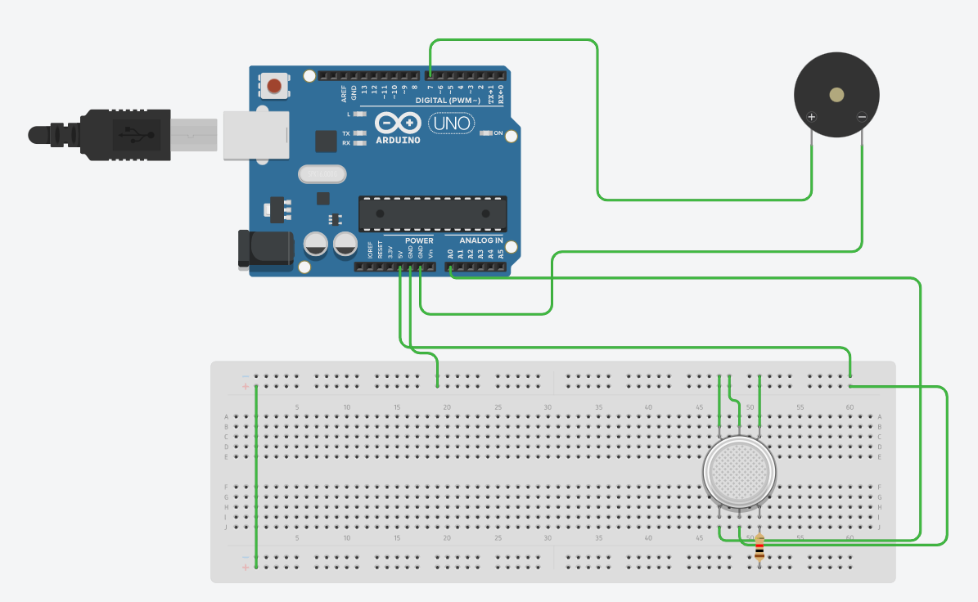

|  |  |
| --- | --- |
| Code:- |  |

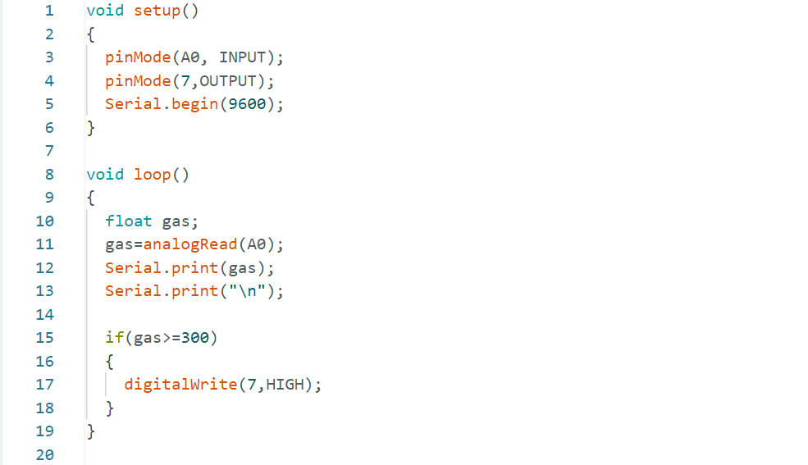

|  |  |
| --- | --- |
| Conclusion:- |  |

* In This Experiment, We Learnt That How To Get Readings of temperature Sensor’s Reading on LCD.